AWS Cloud Quest  
**Task 10. Auto Healing and Scaling Applications**

Create and configure an Amazon EC2 Auto Scaling group that follows scheduled scaling activities to add and remove EC2 instances.

|  |  |
| --- | --- |
| Person | Hi! I own the city’s only gaming café. Thanks for answering my call for help. |
| Me | I’m a gamer too. How can I help? |
| Person | Gaming parties are so hot right now, and we’re allowing our users to host their own servers for various games in our café.  We have a maximum number of Amazon EC2 instances that we allow users to provision each day, but we do not have controls to enforce this rule.  So, we have a couple of issues. First, if an EC2 instance crashes, we have no automatic way to replace it.  Second, we want users to stay within their server provisioning limit. |
| Me | This sounds like a perfect opportunity to use auto scaling groups.  You can set up launch templates for your user’s game web servers. In those templates, you can configure the number of EC2 instances to automatically scale up or scale down based on demand.  You can also set hard limits on the number of instances that users can provision. |
| Person | Oh, that sounds excellent! But we have another issue.  A large party is booked from 8:00 PM to 1:00 AM every Tuesday. The moment the party starts, we want servers up and ready. The moment the party ends, we want the servers to shut down.  How can we make sure that user game servers start up and shut down at specific times? |
| Me | Using auto scaling groups, you can configure scheduled scaling that launches and terminates instances according to a predefined schedule. |
| Person | I think auto scaling group can work for us!  Can you configure an Auto scaling group for our gaming servers? |
| Me | Accepted! |
| Person | Thanks for helping us! |

**Learning Objectives**

* Create an auto scaling group with launch configuration.
* Configure scheduled scaling.

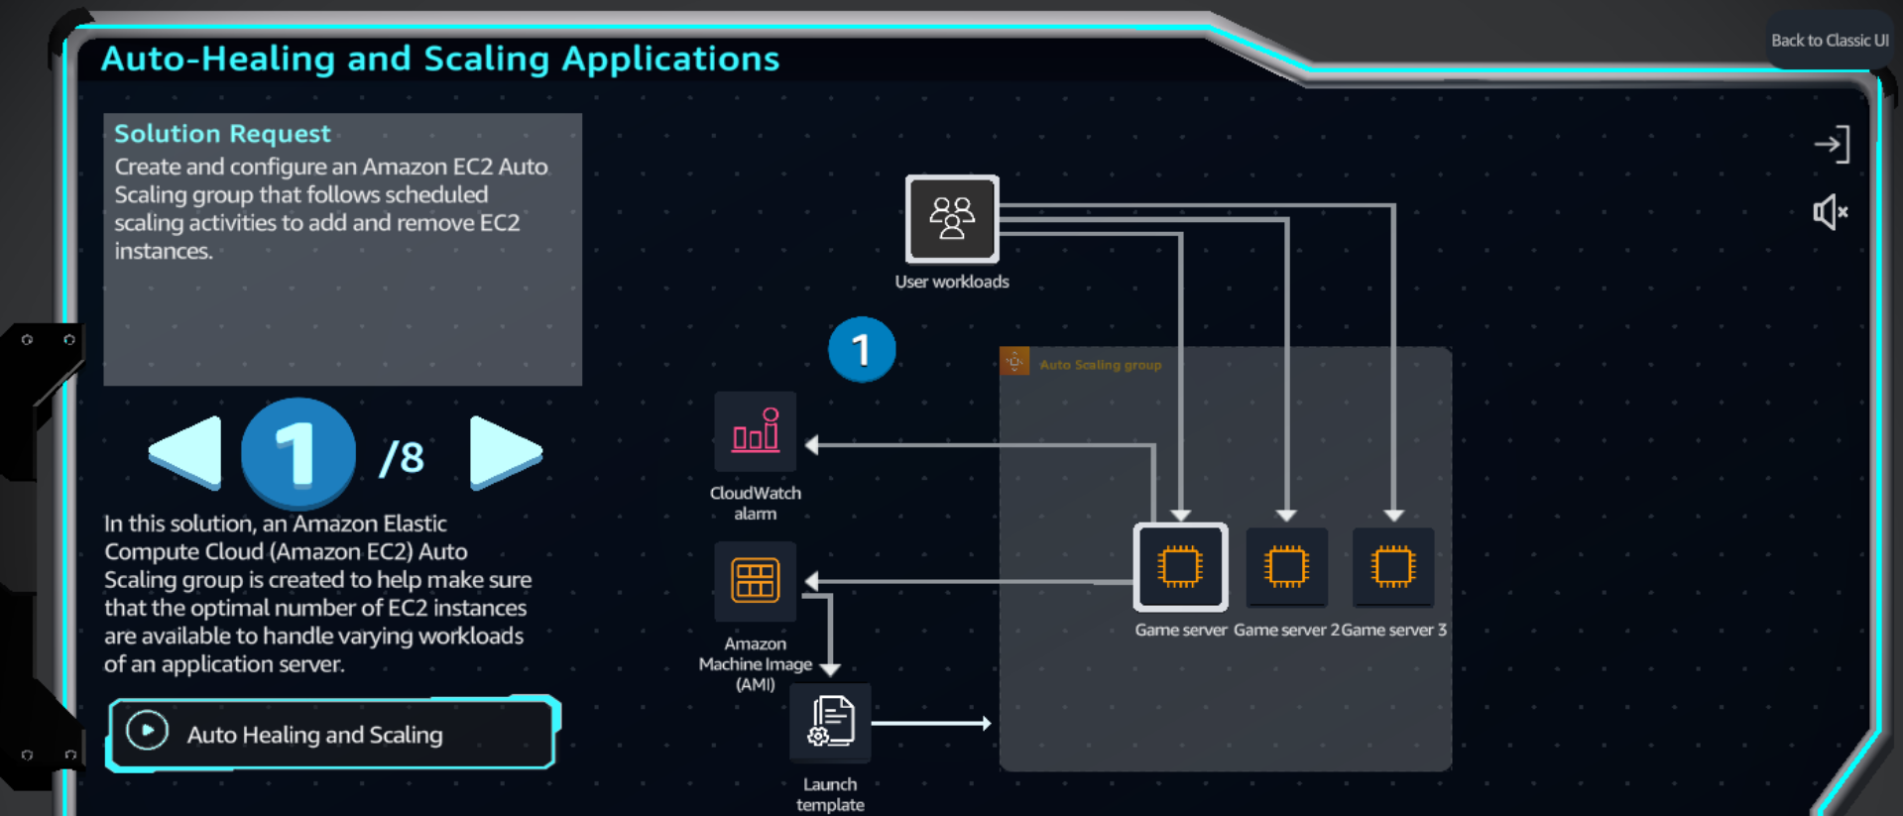

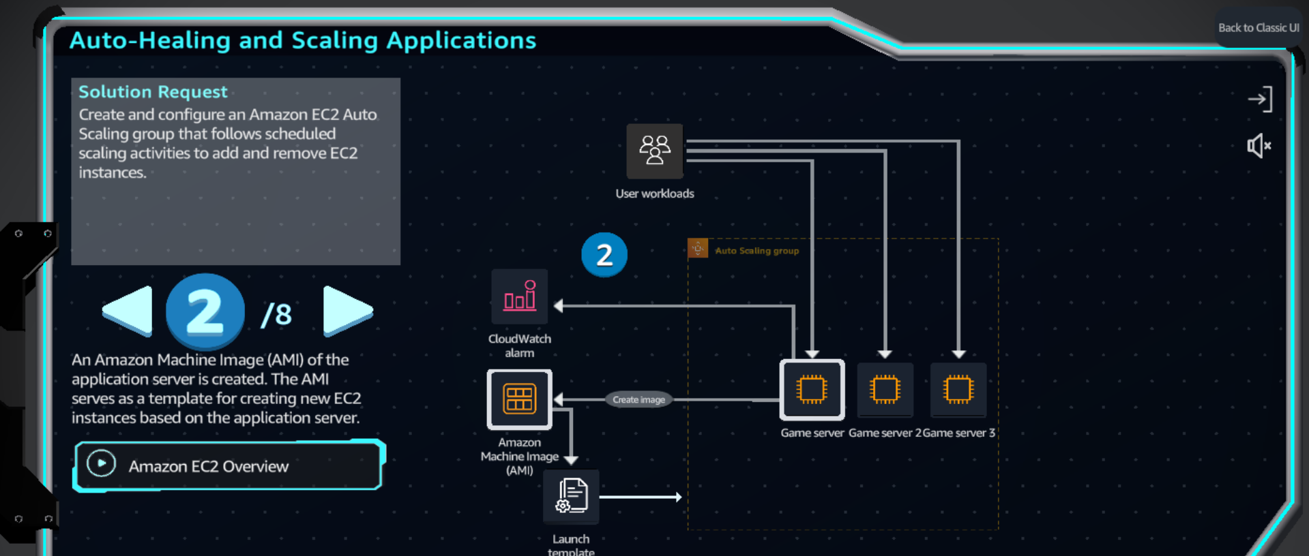

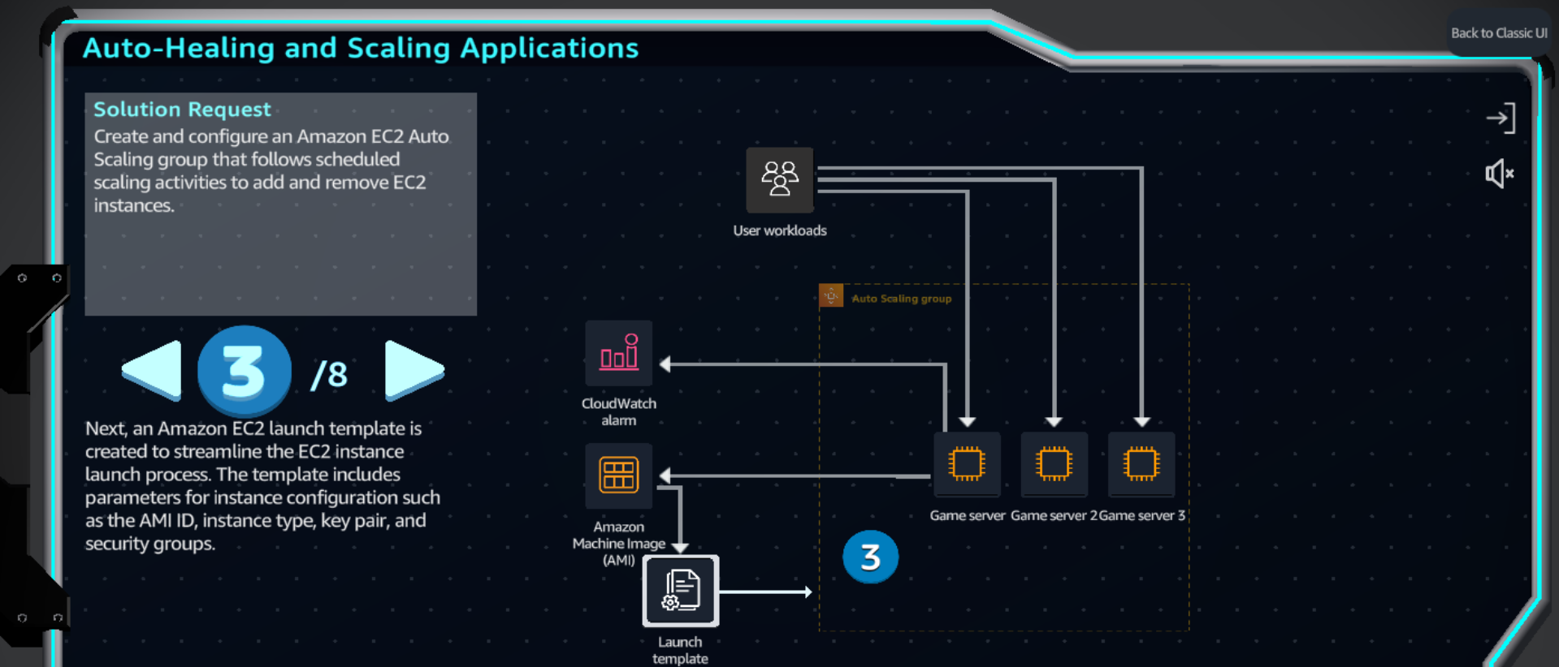

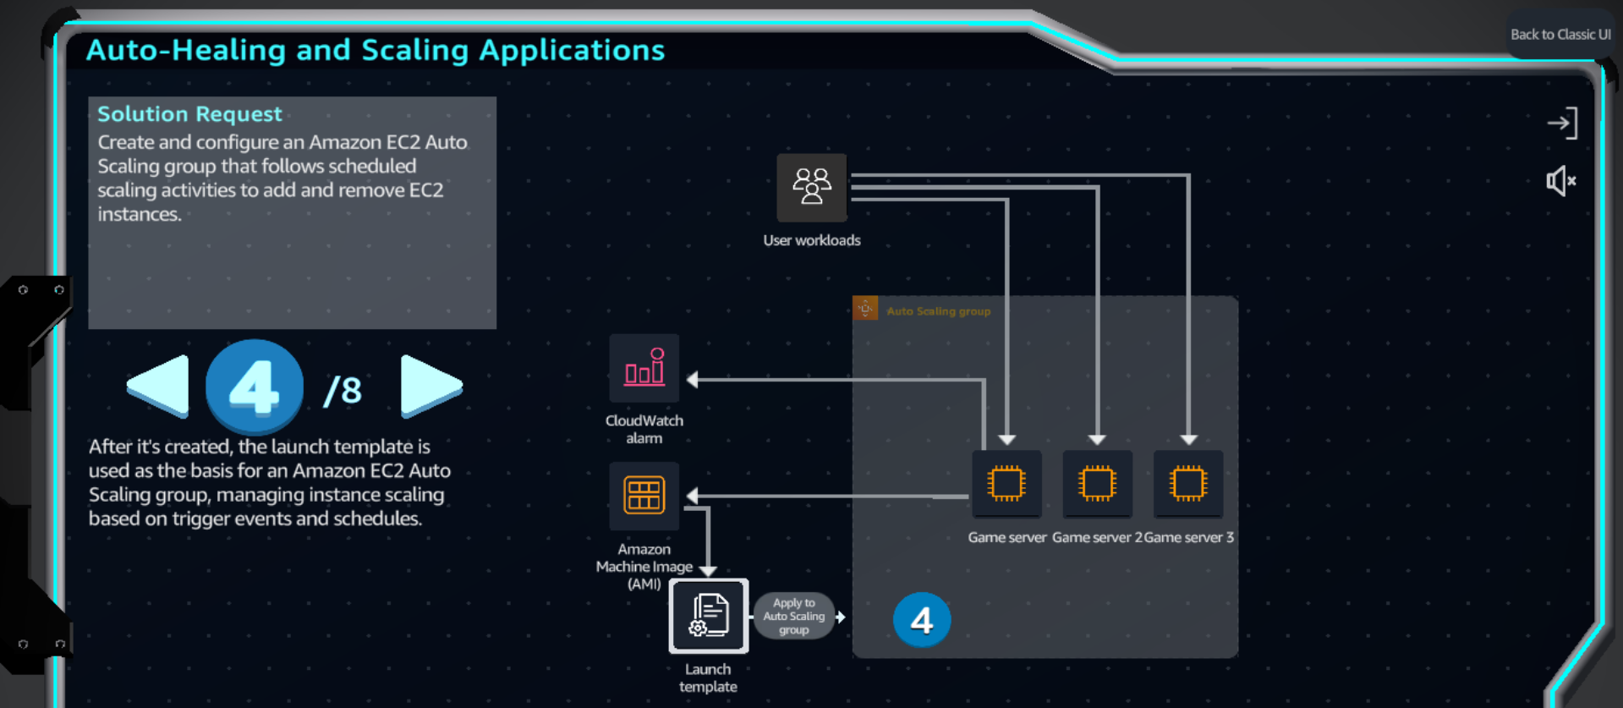

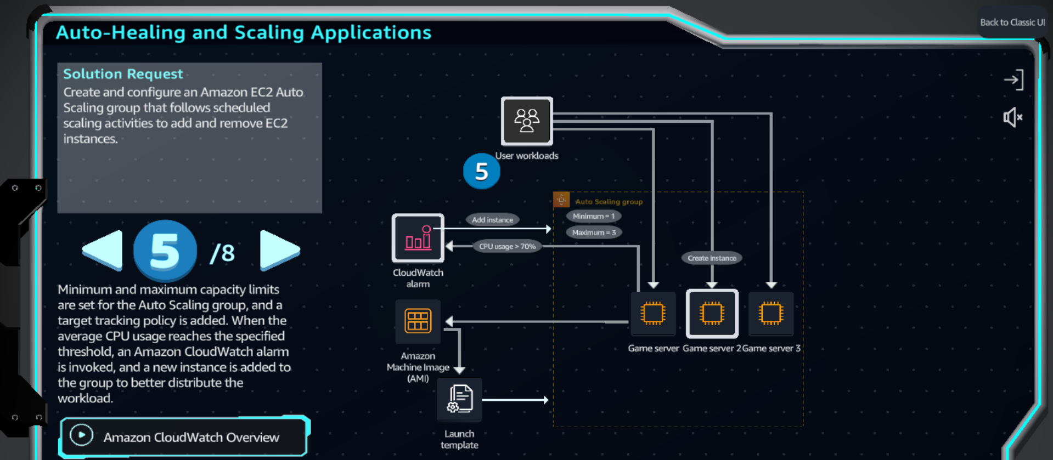

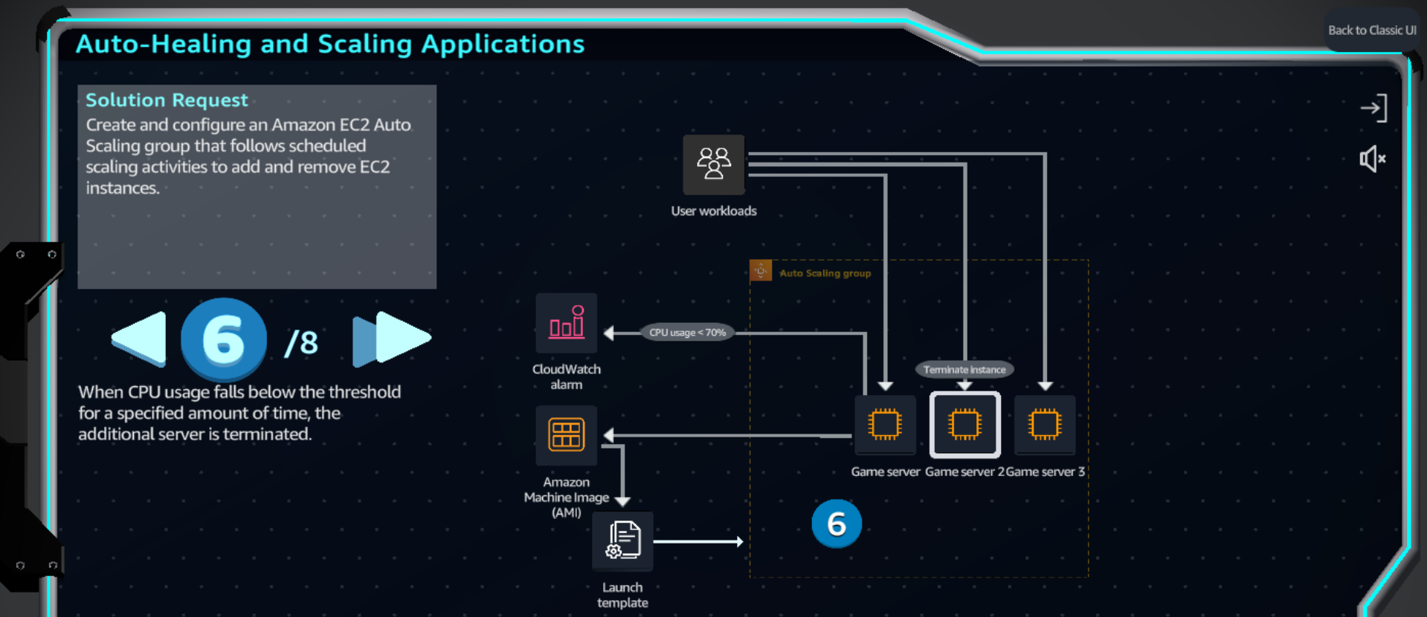

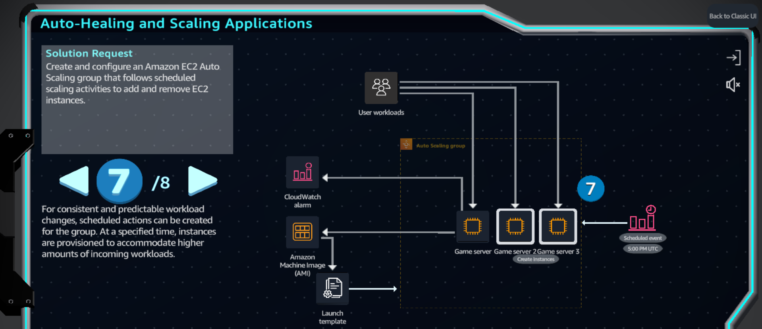

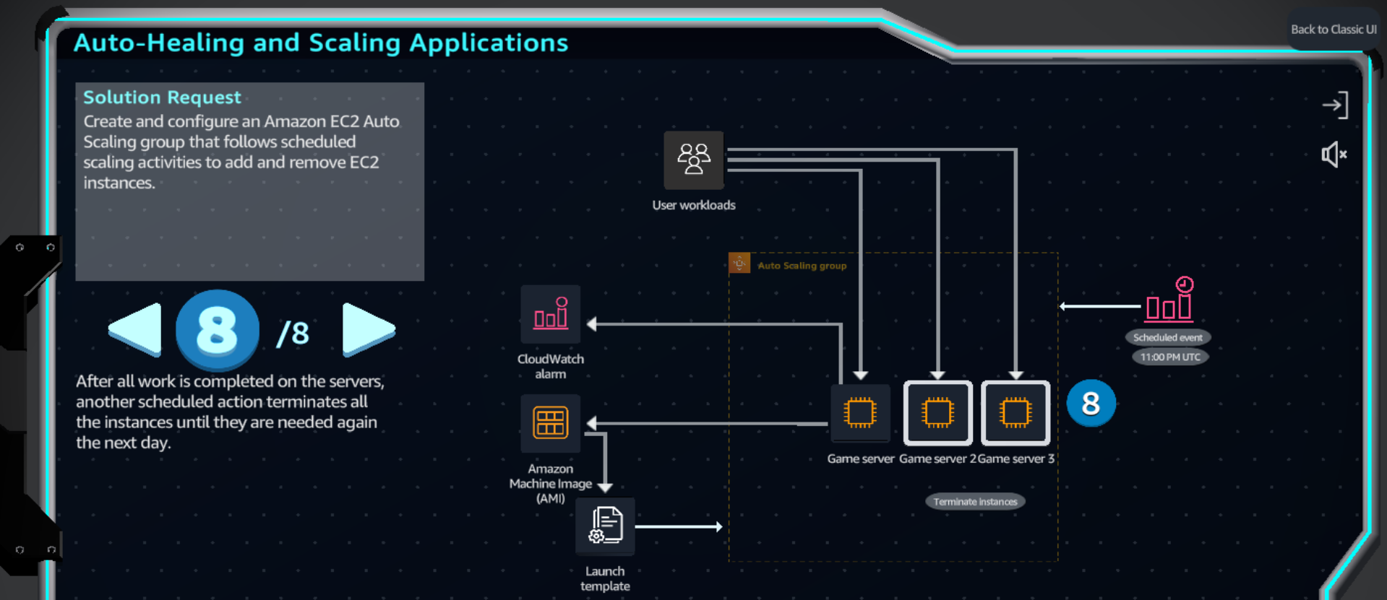

**Practice**

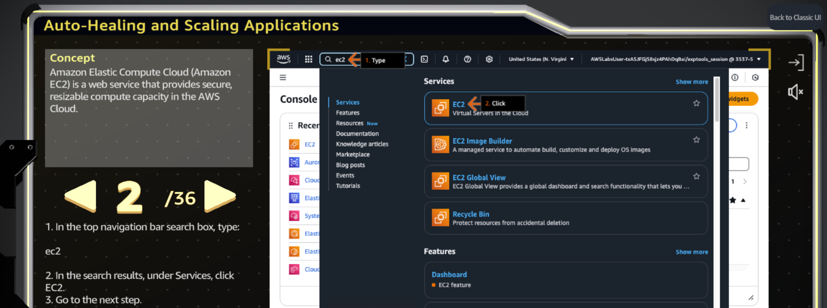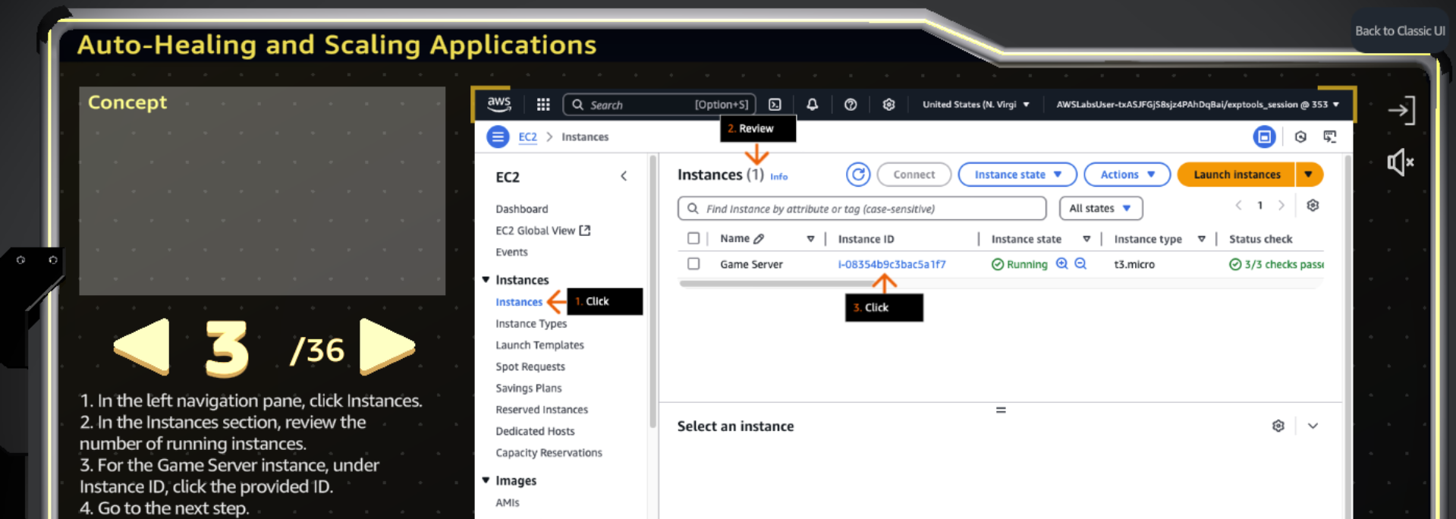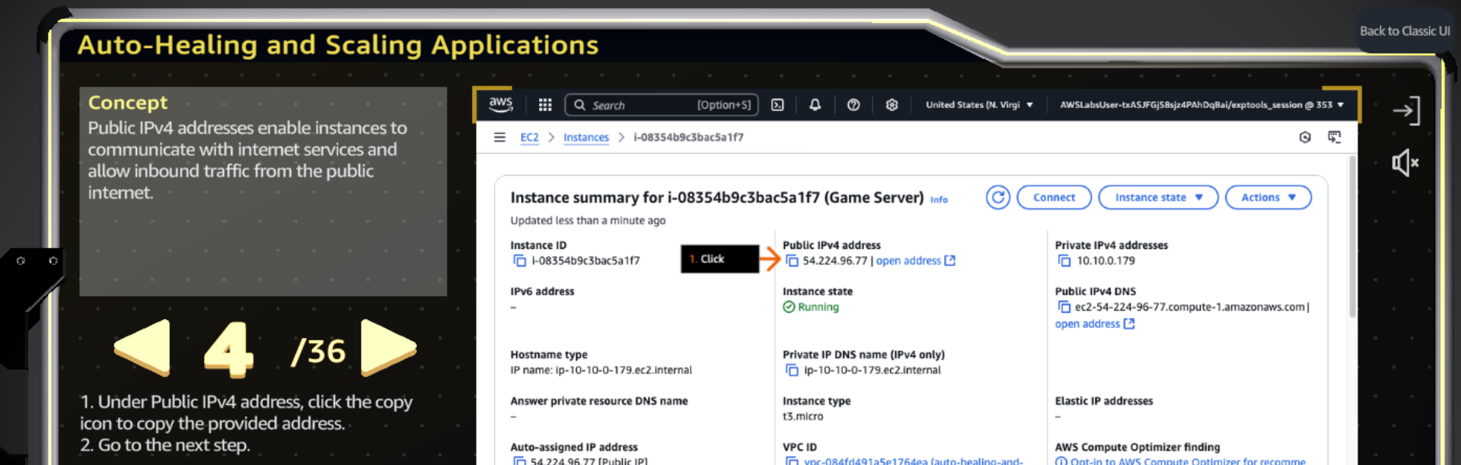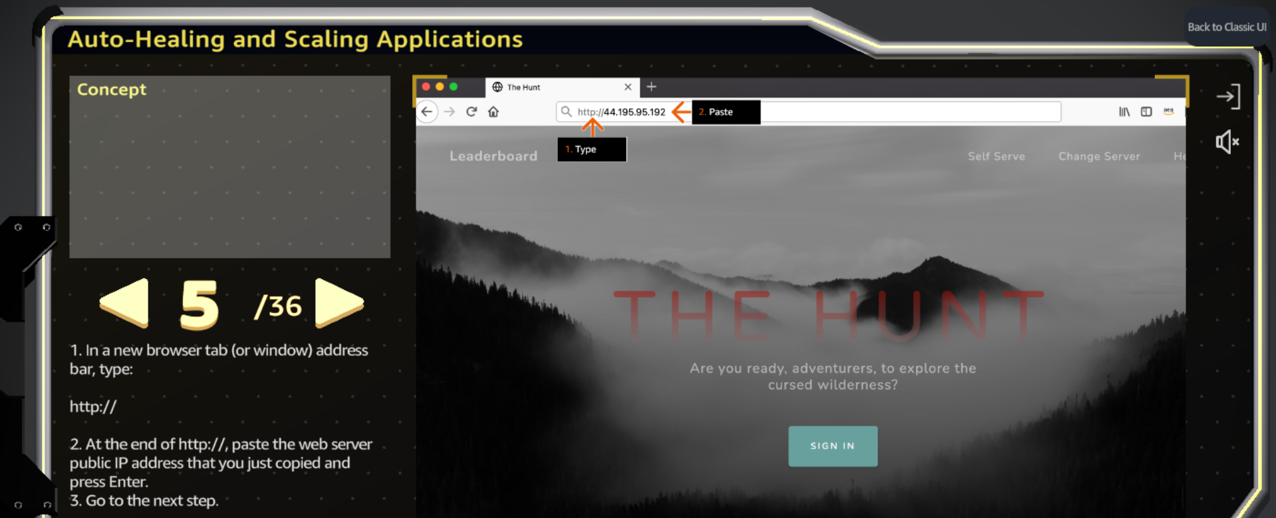

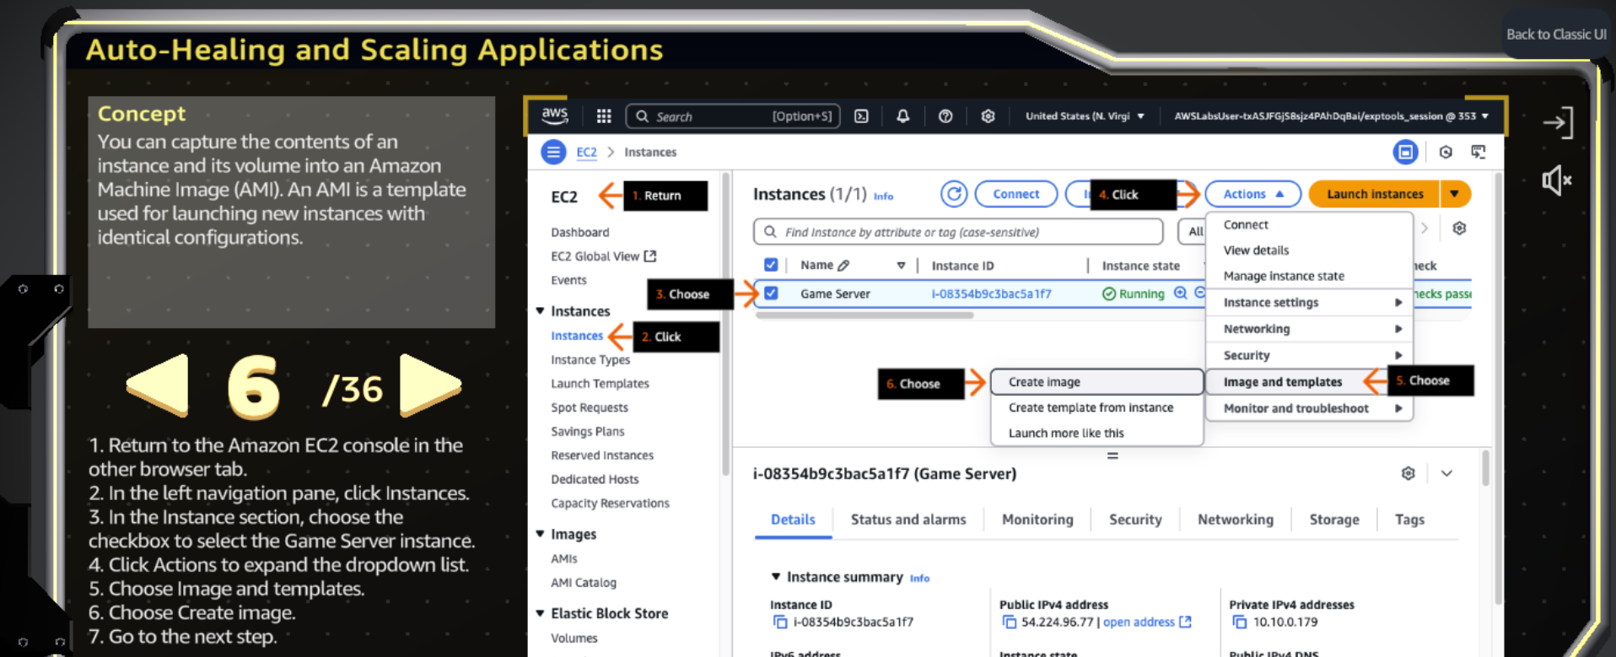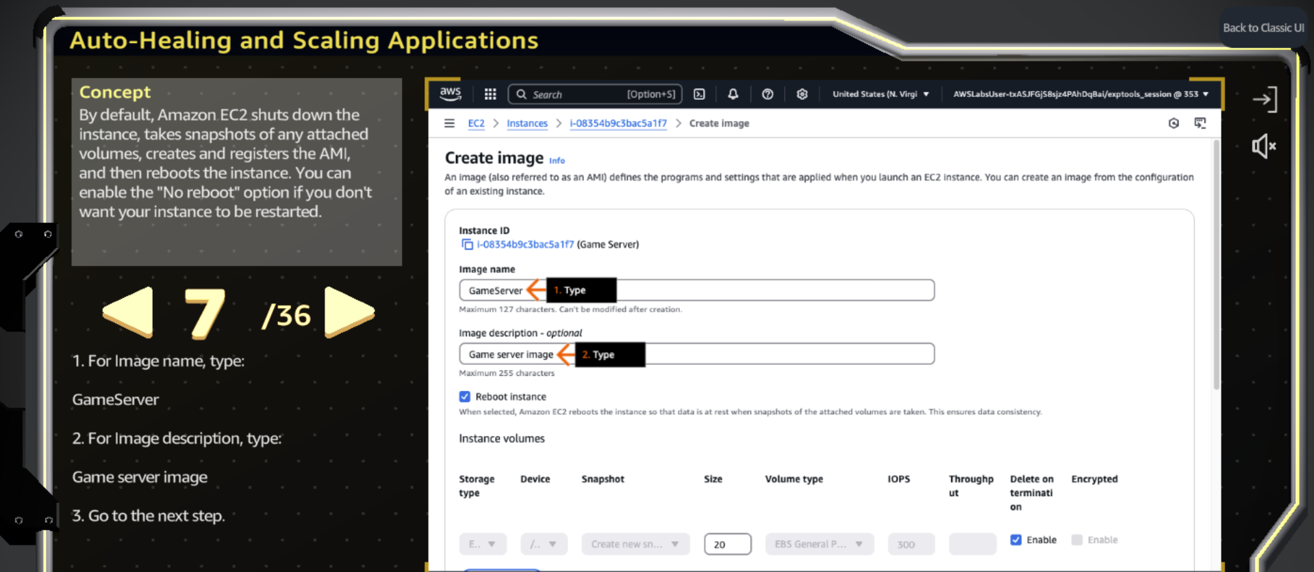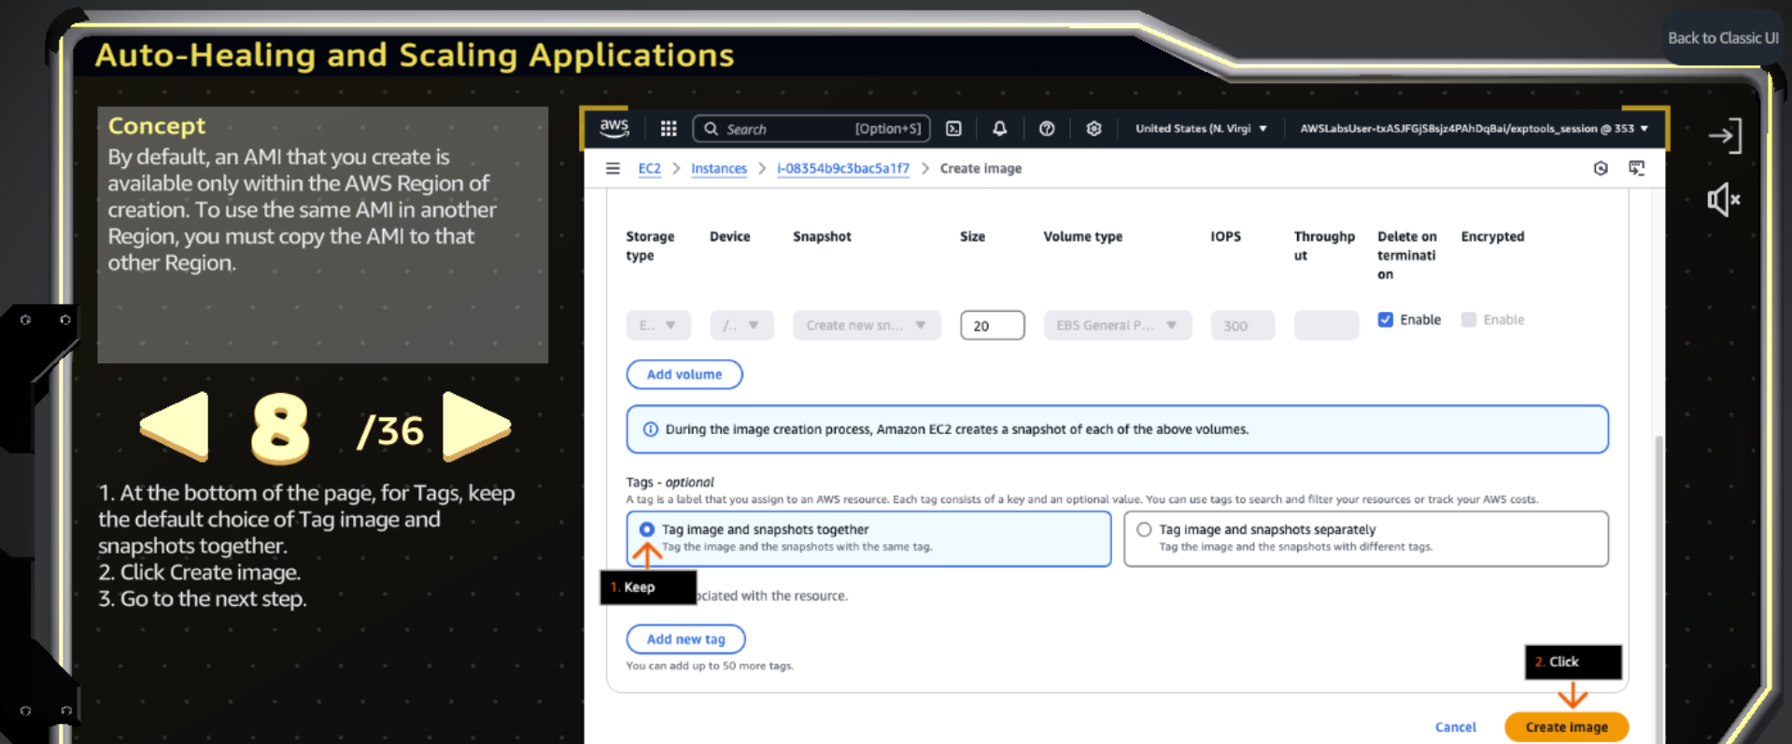

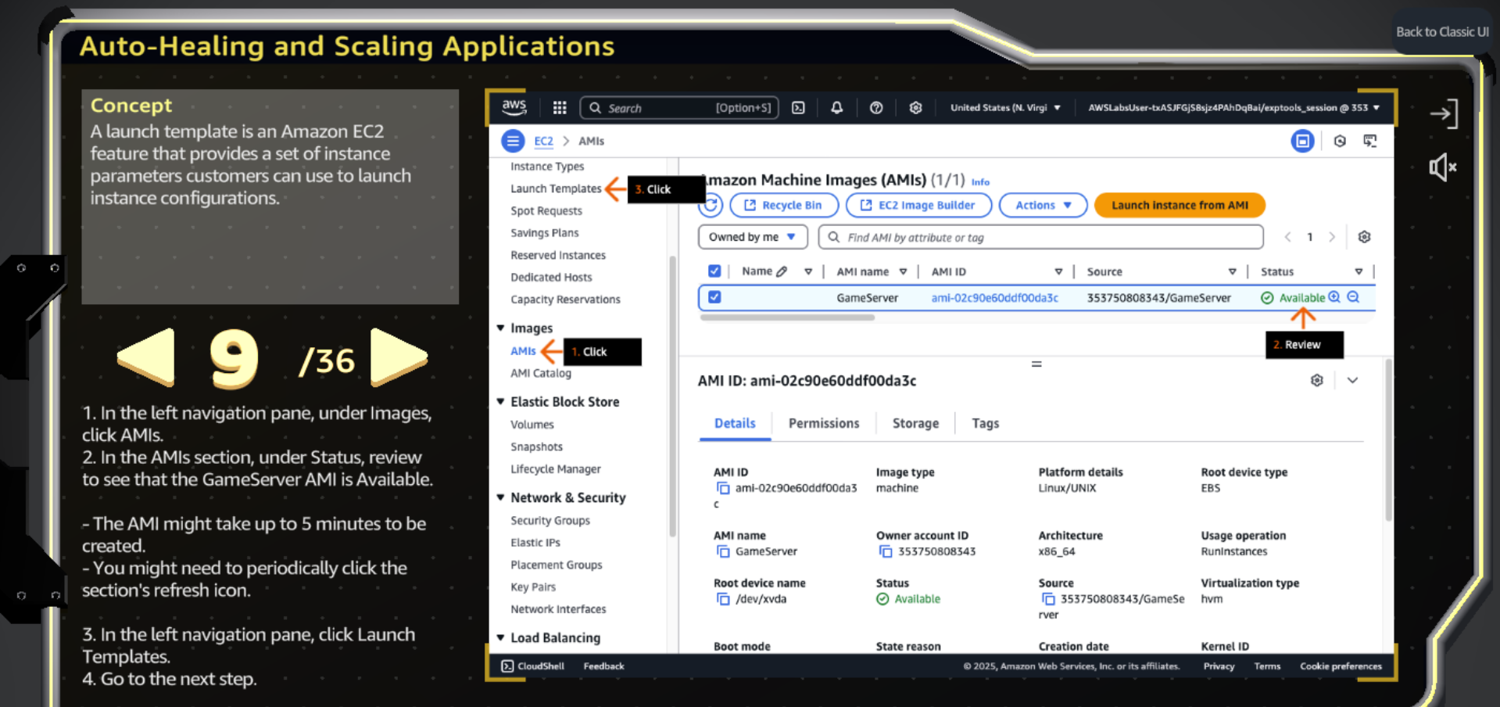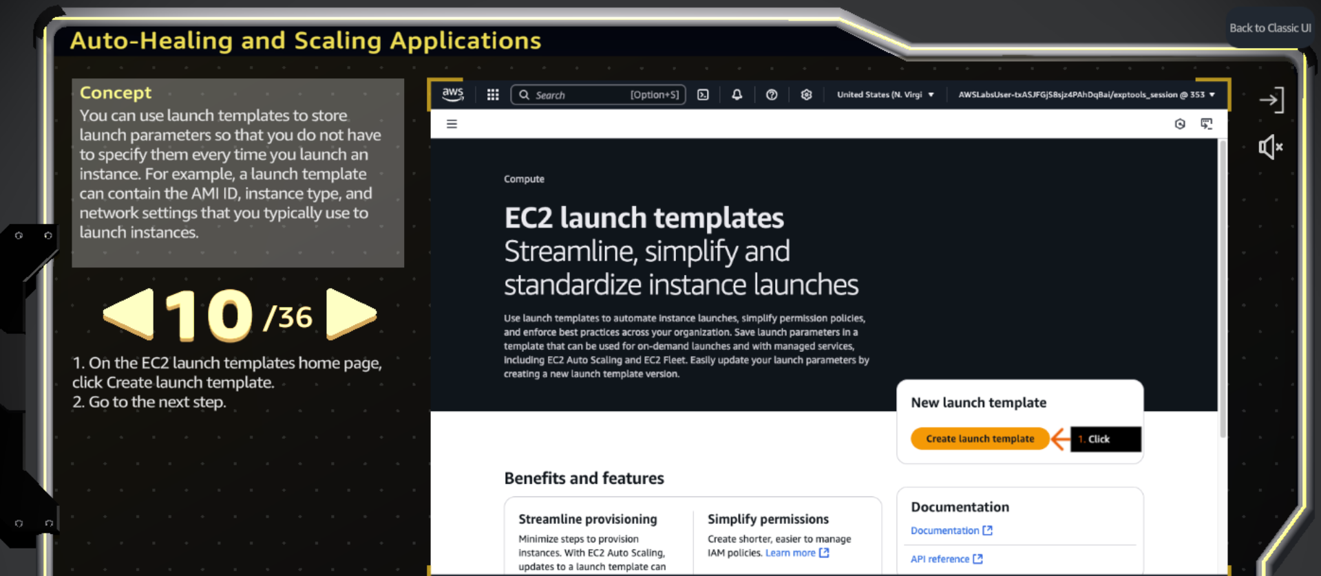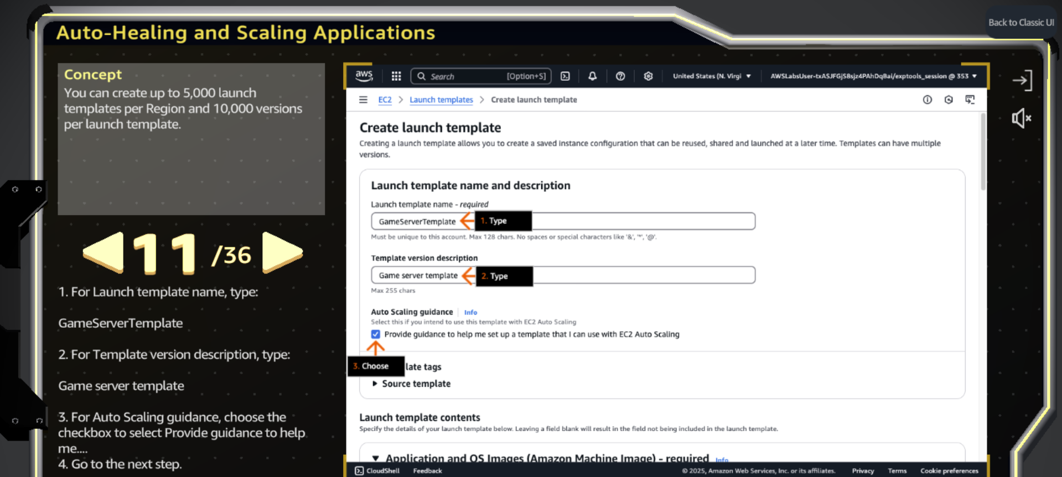

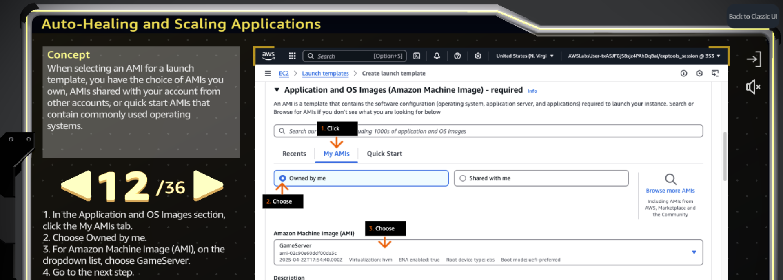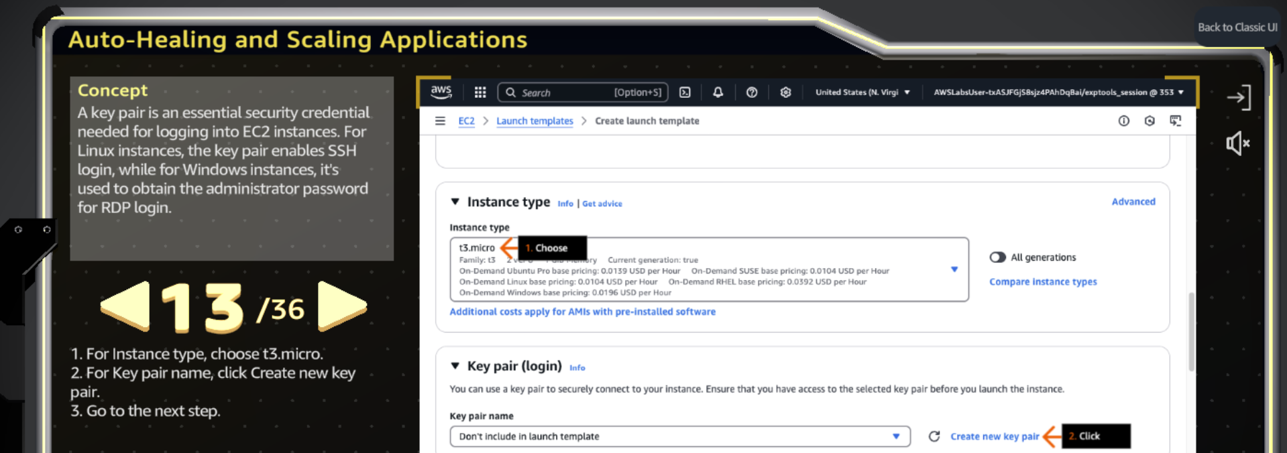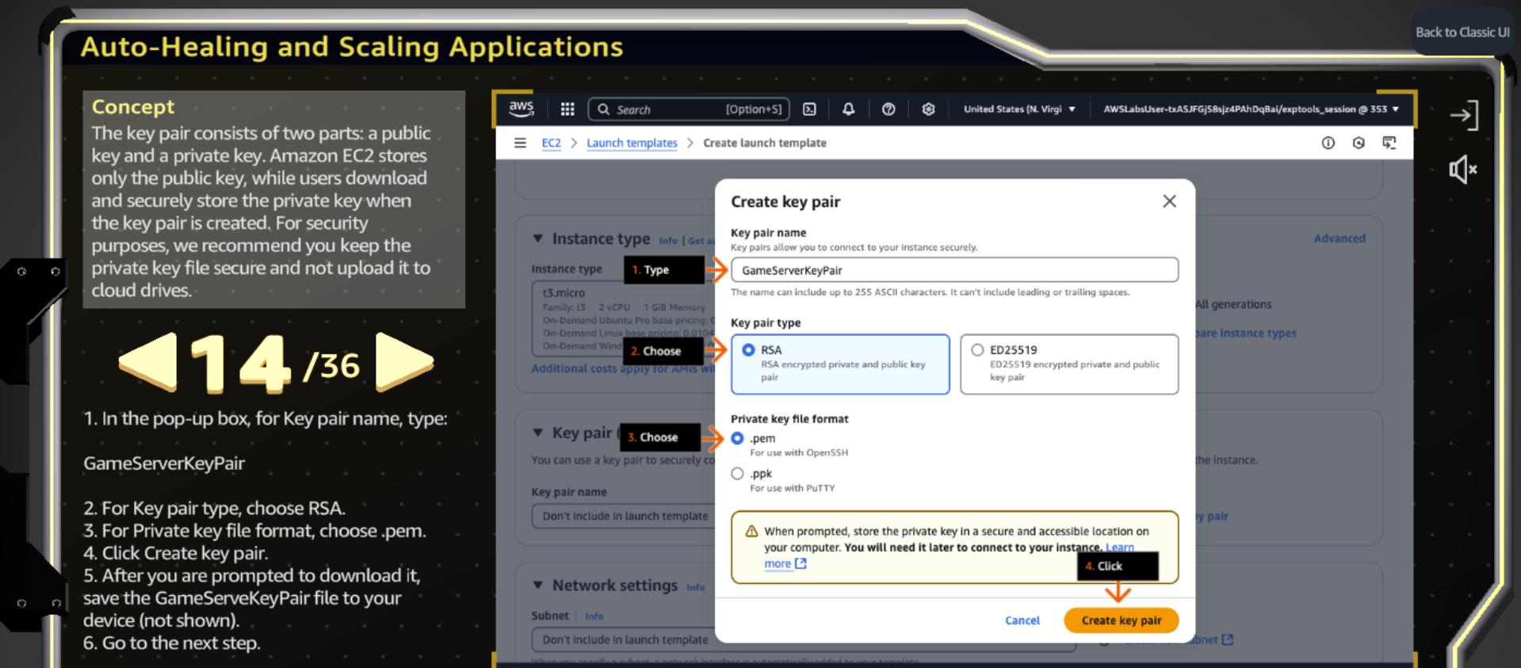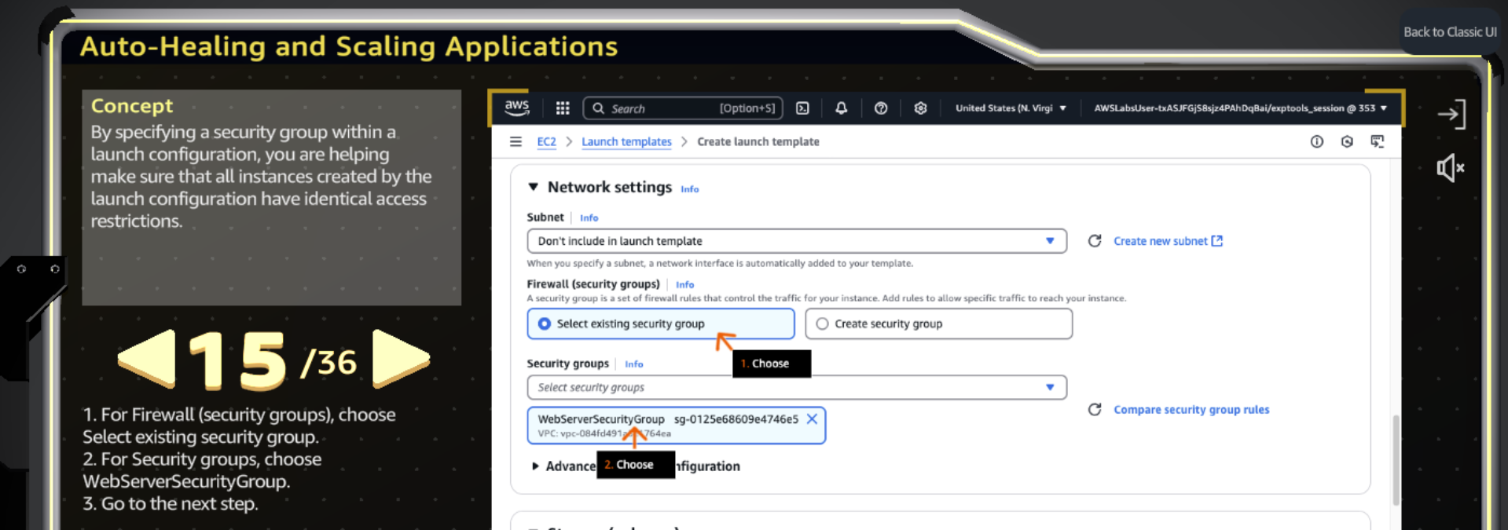

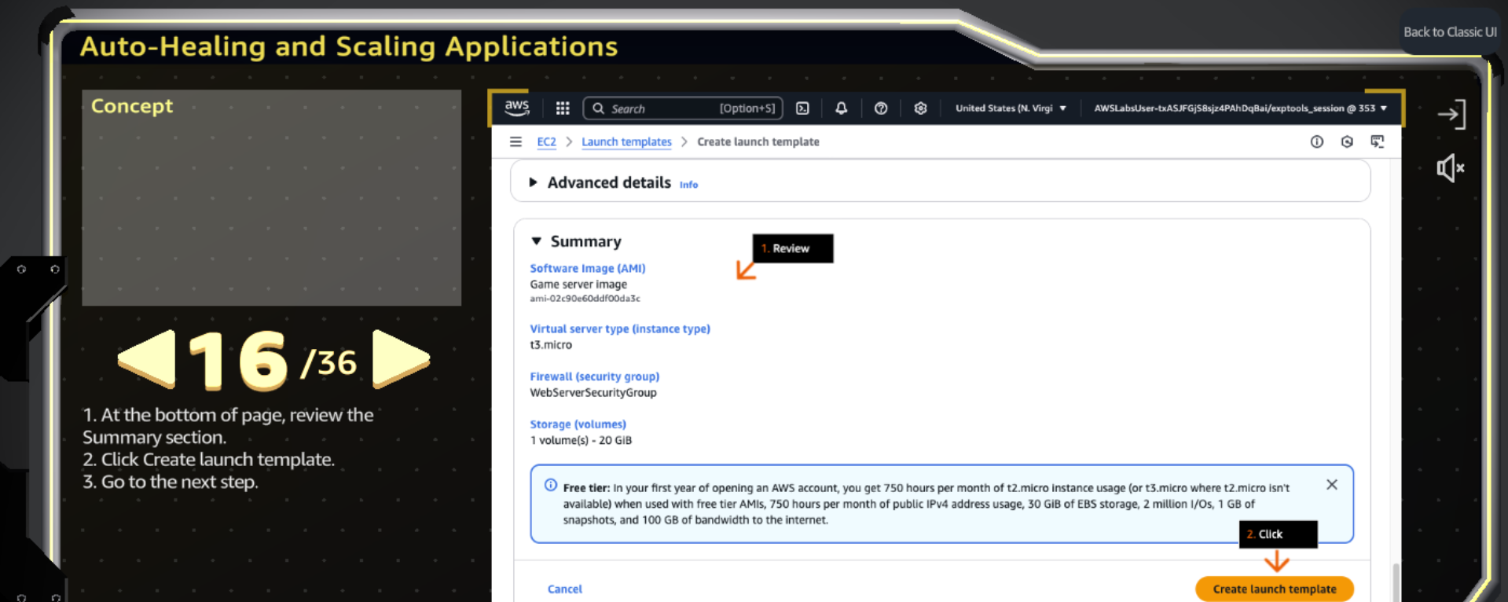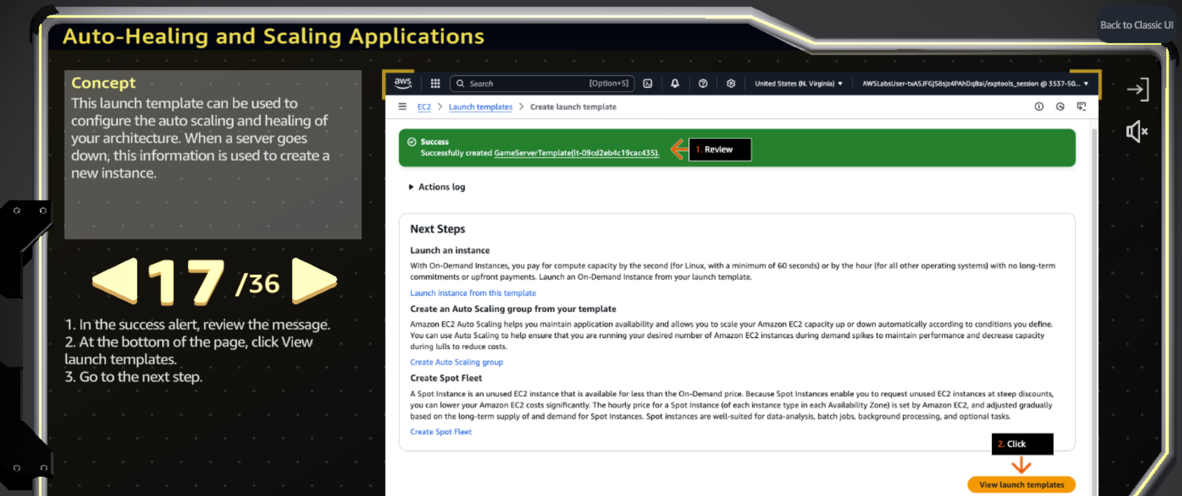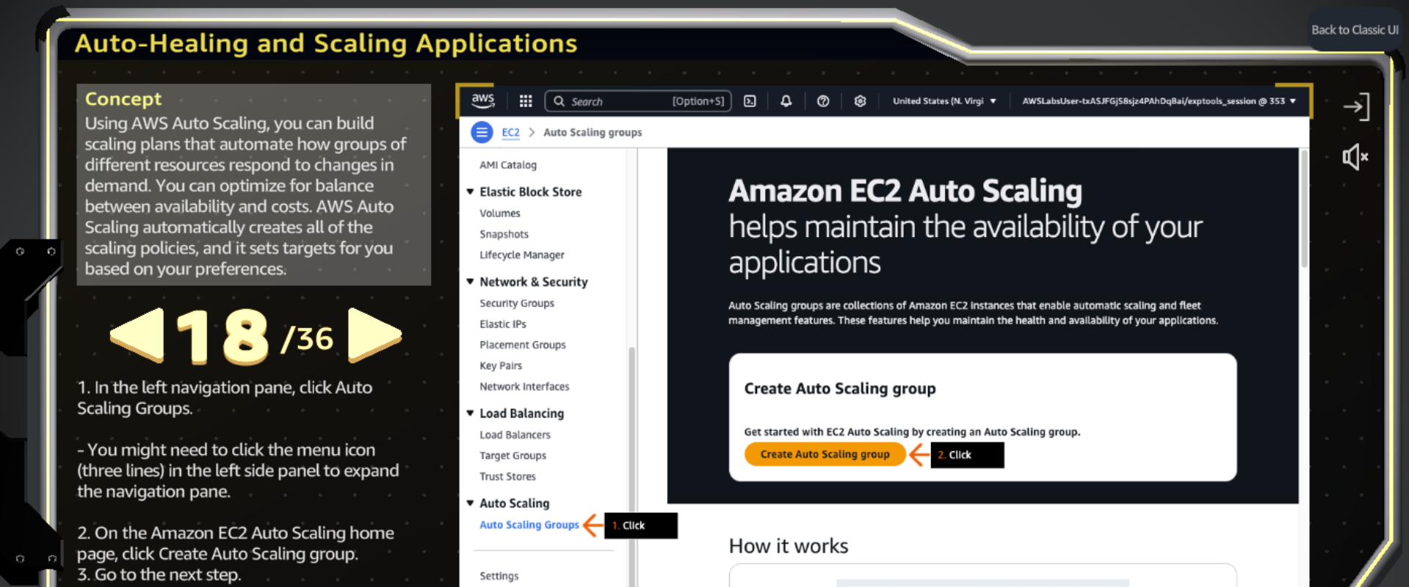

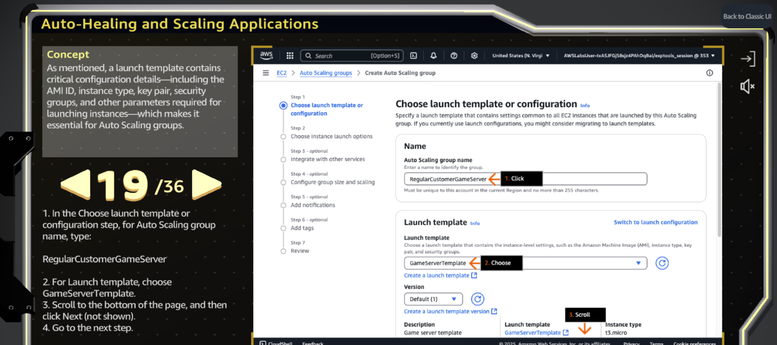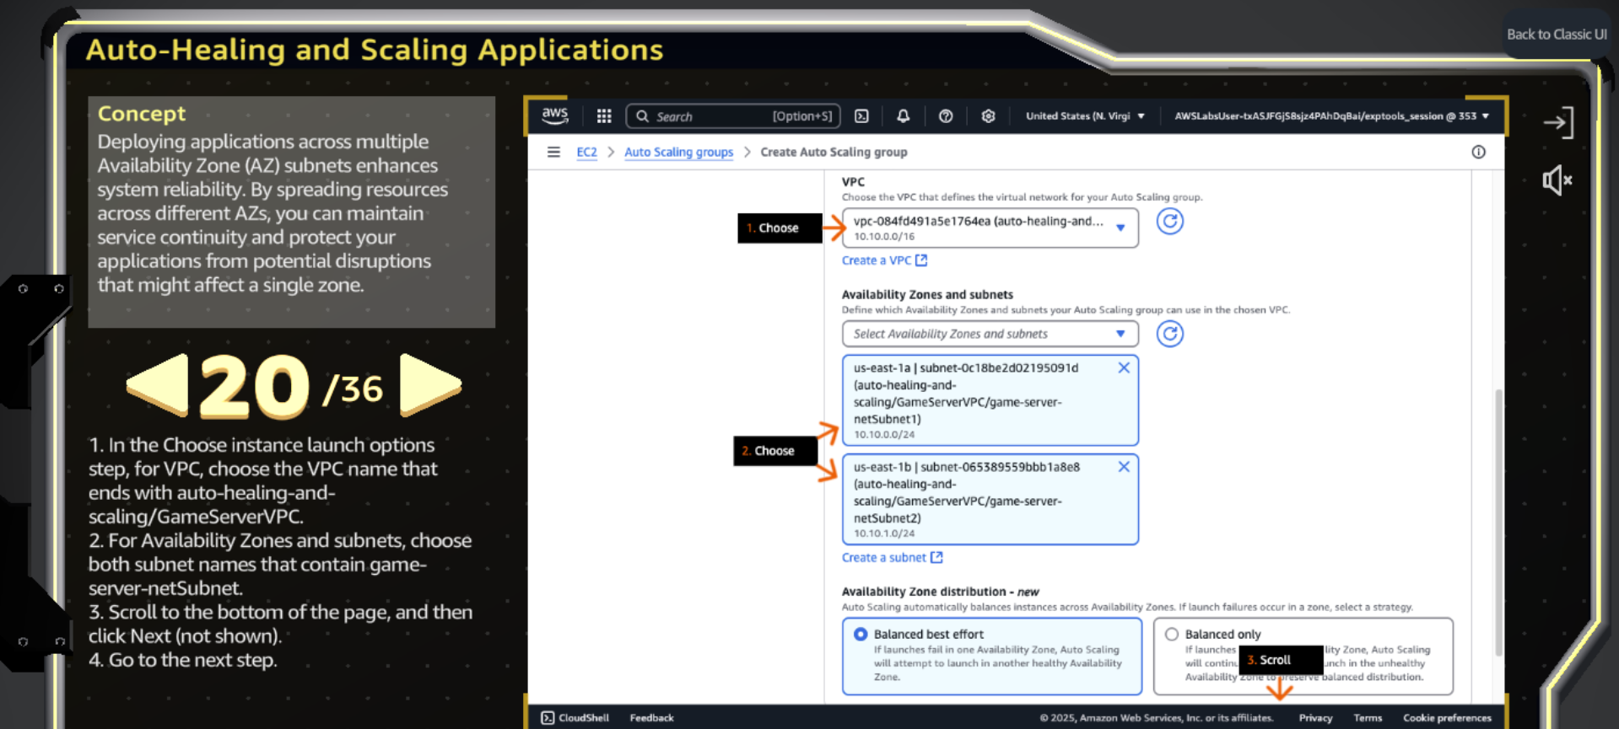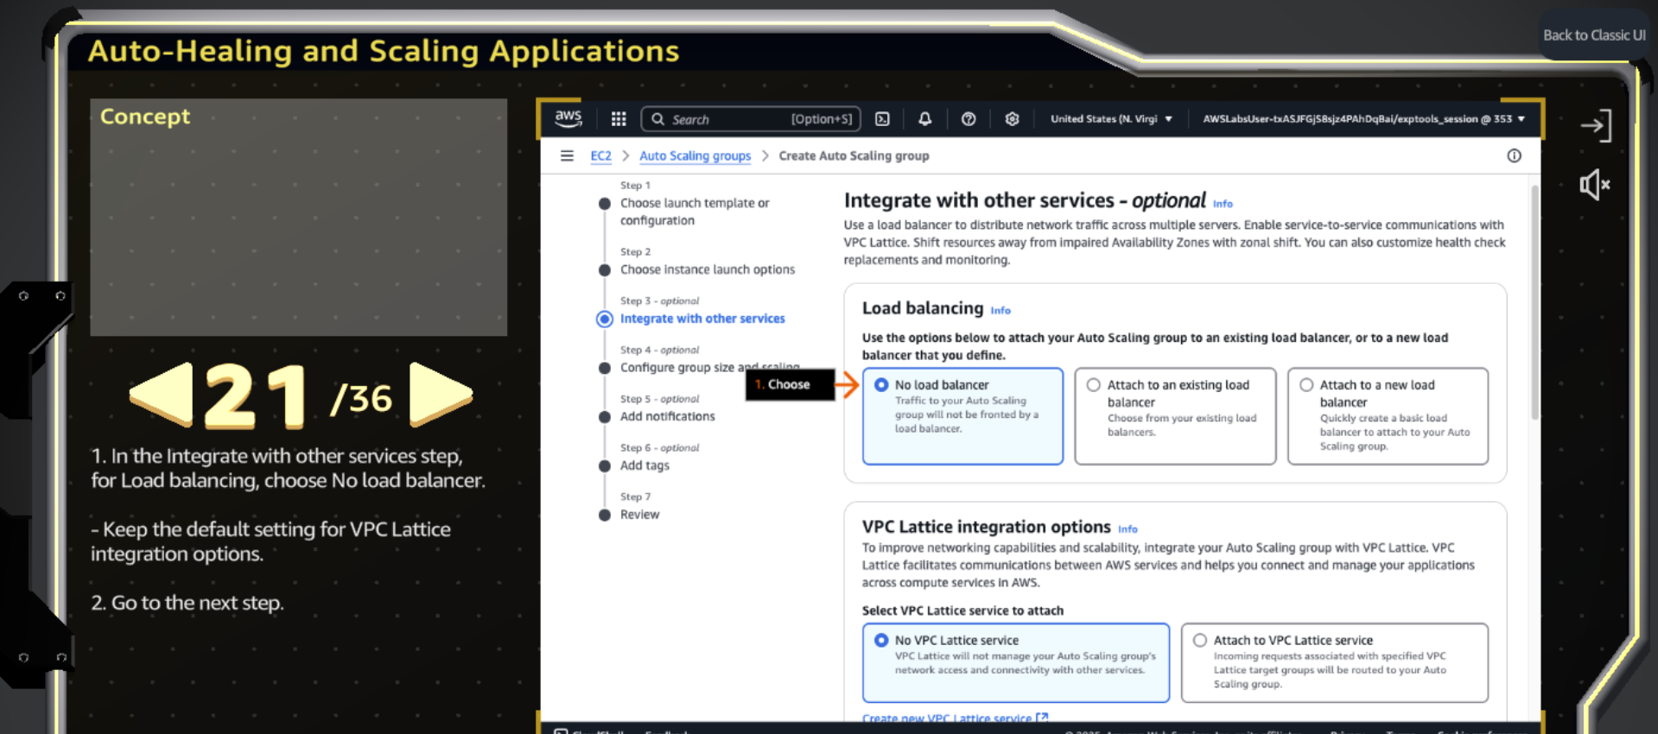

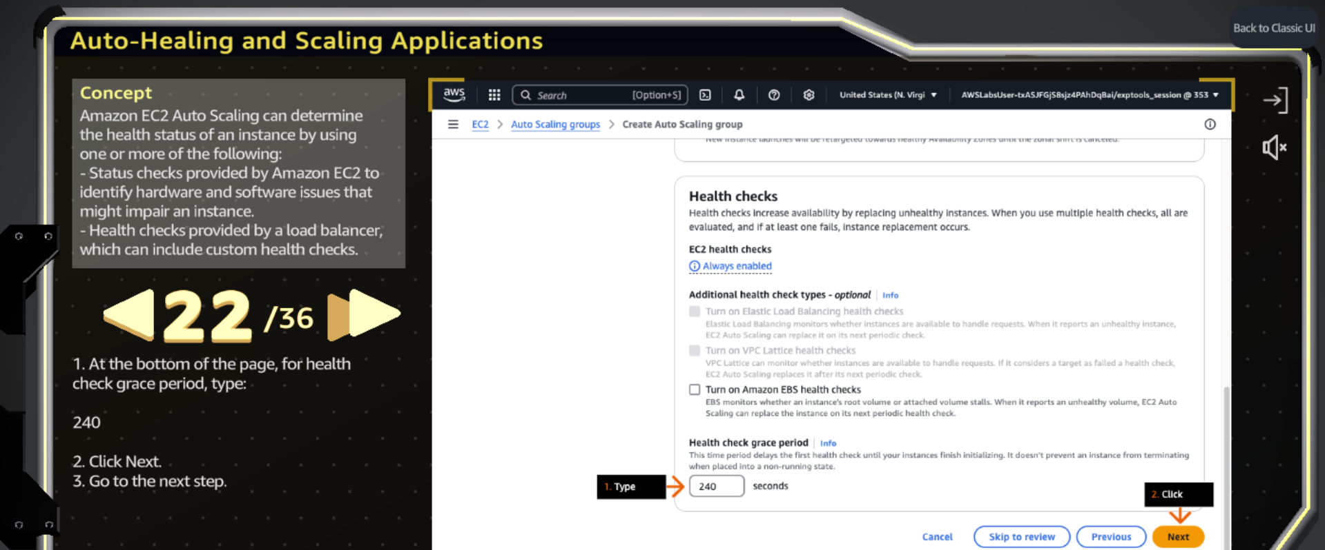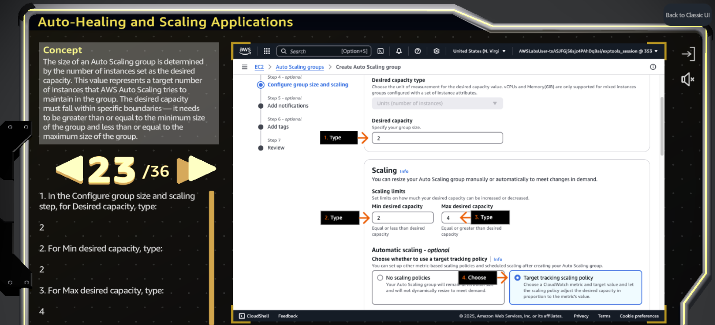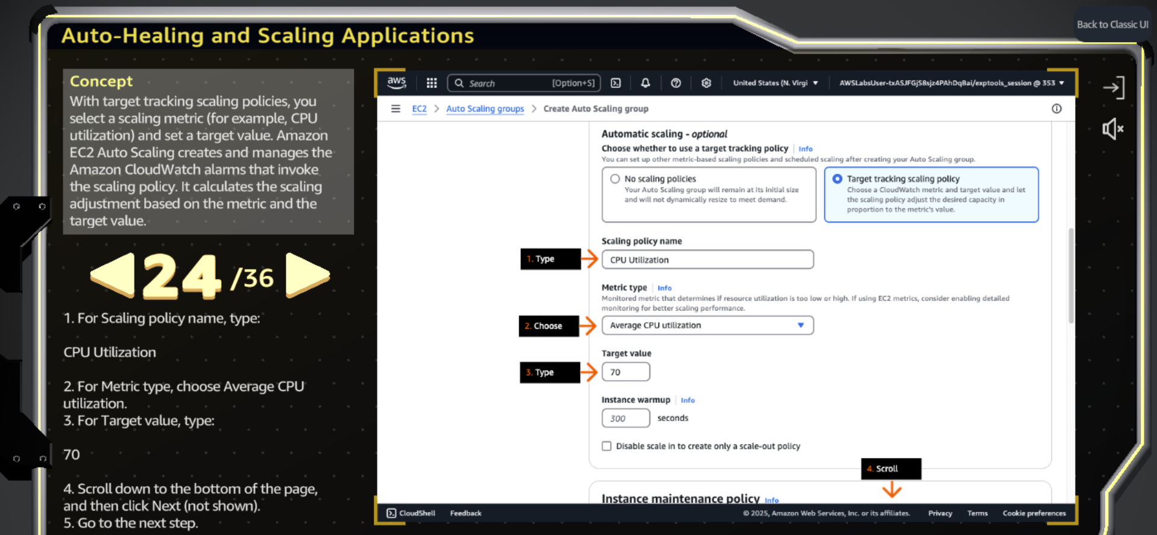

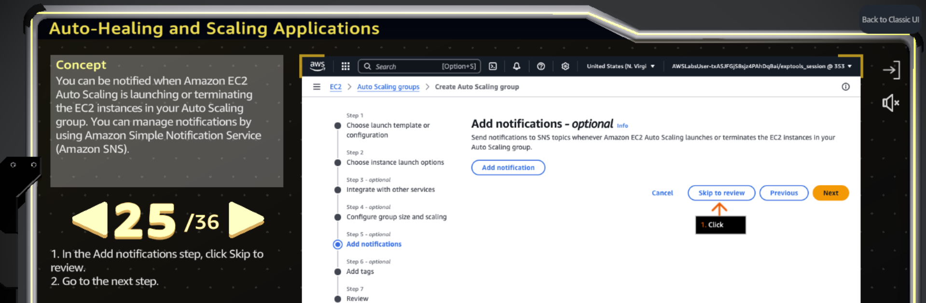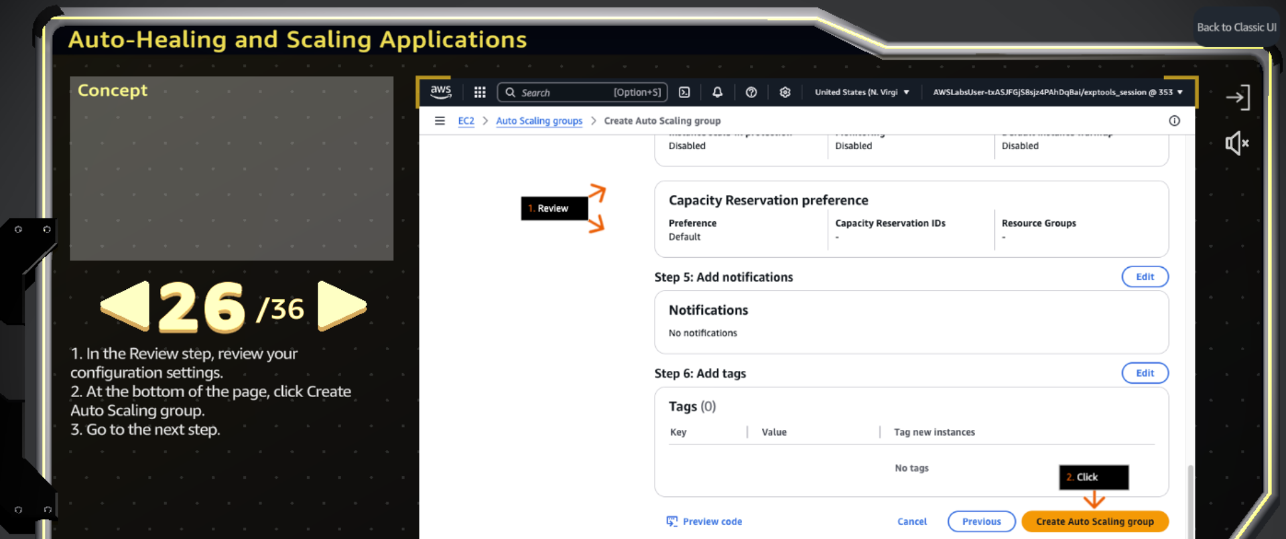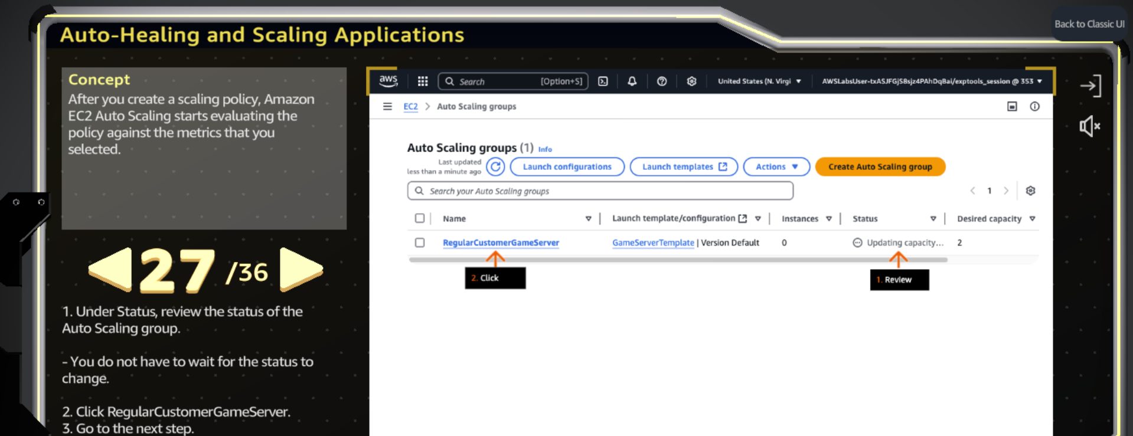

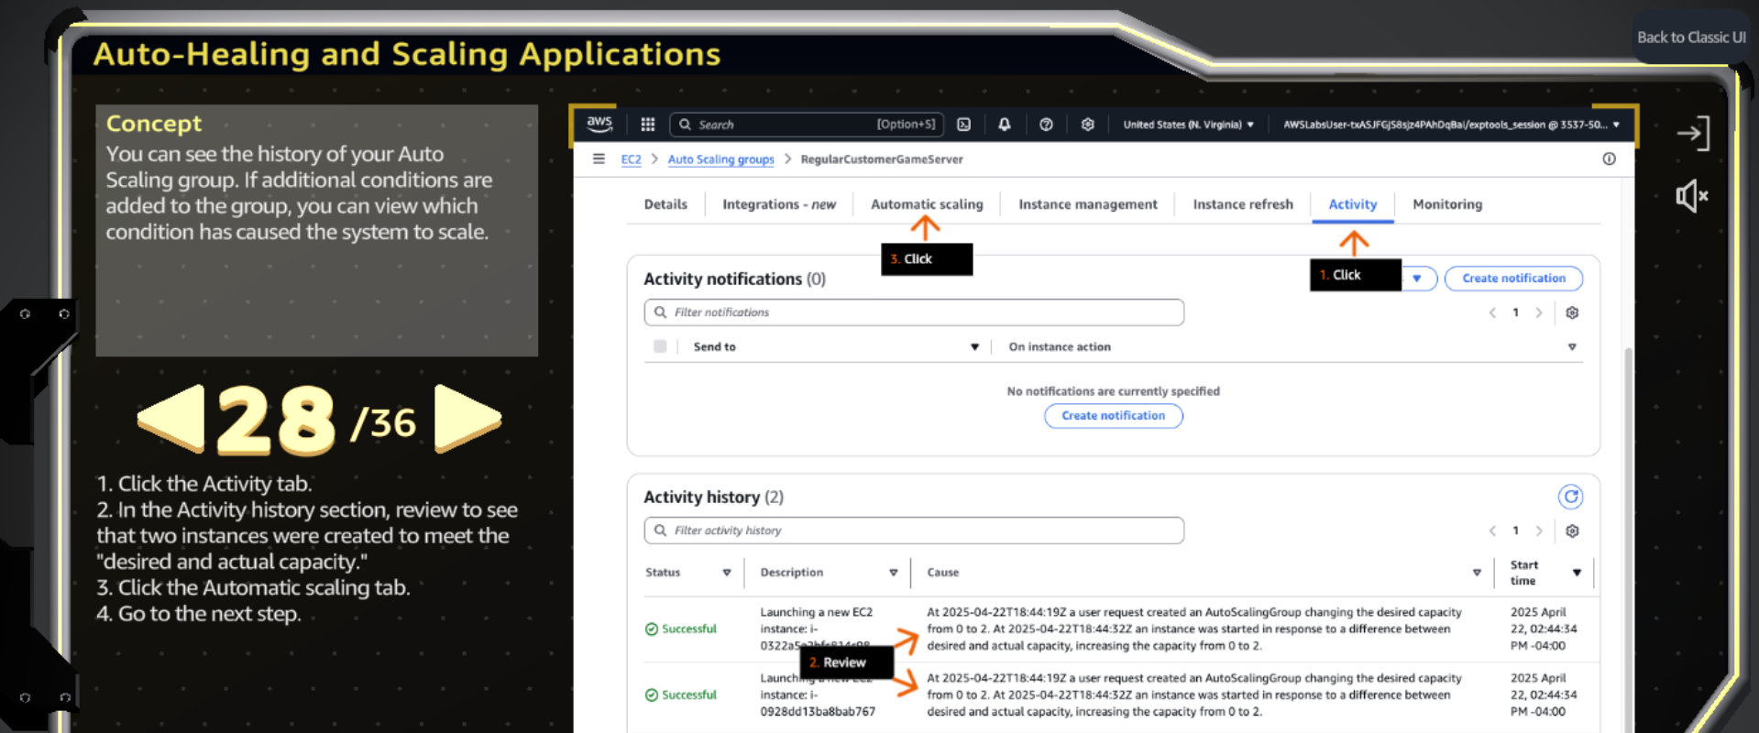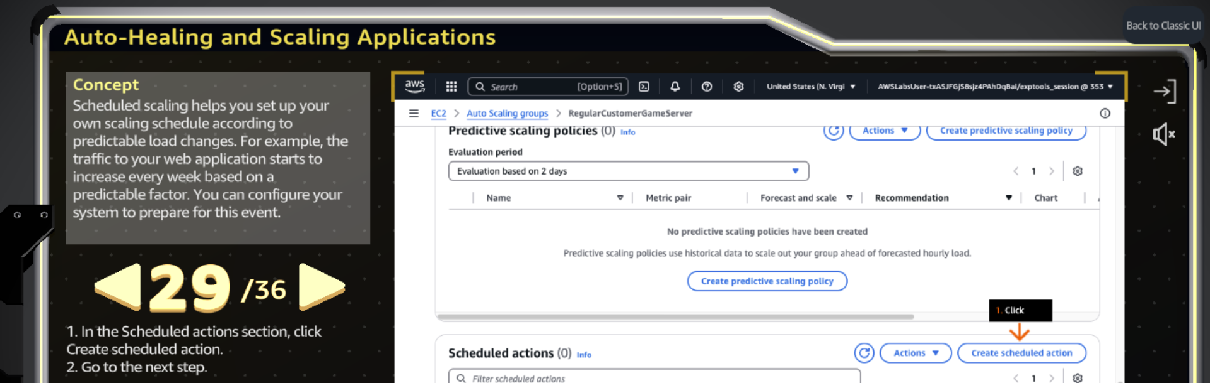

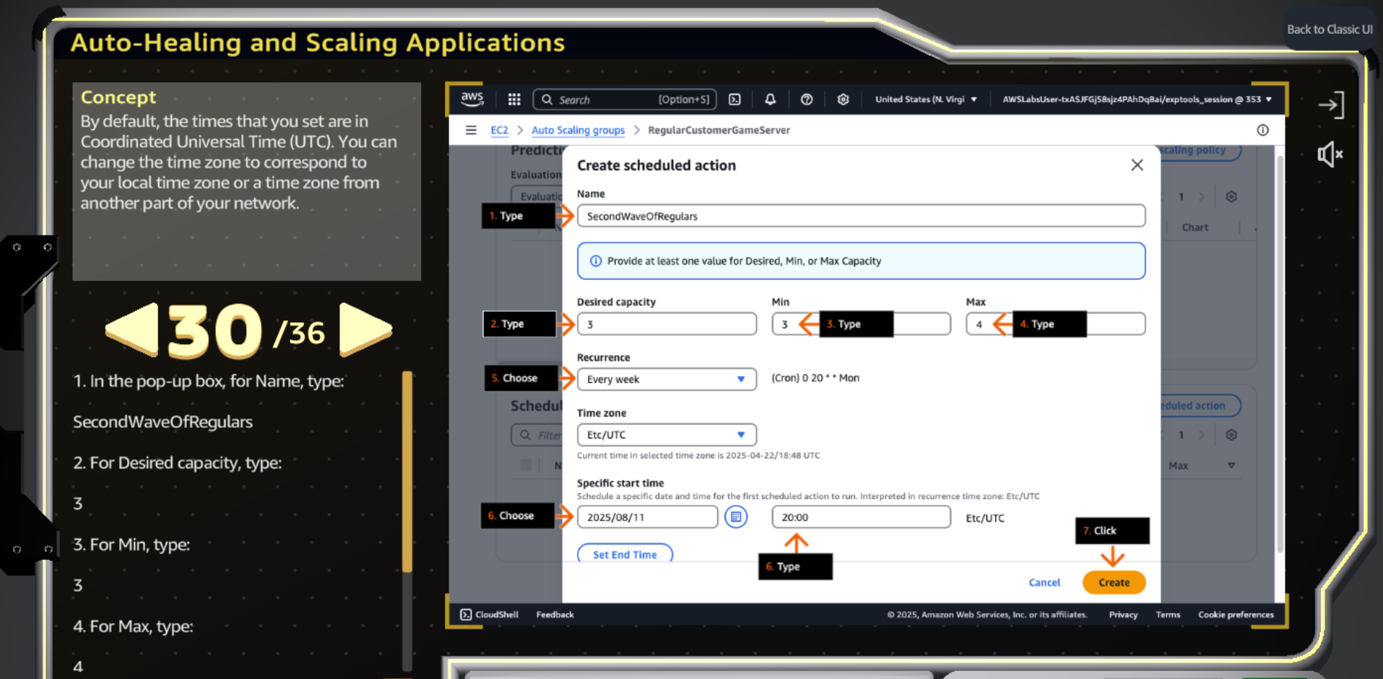

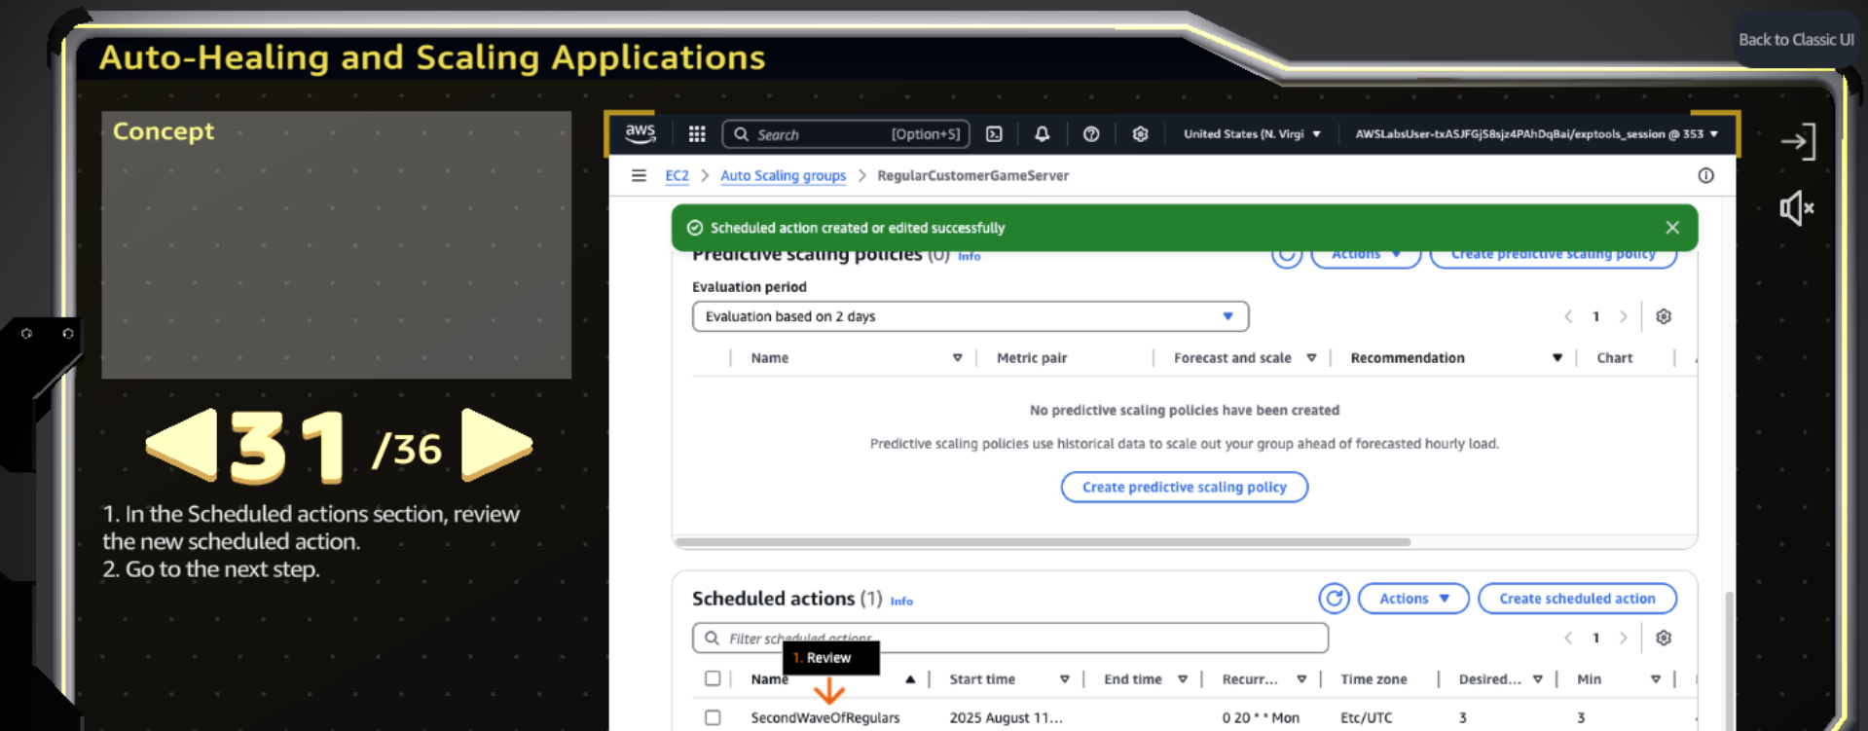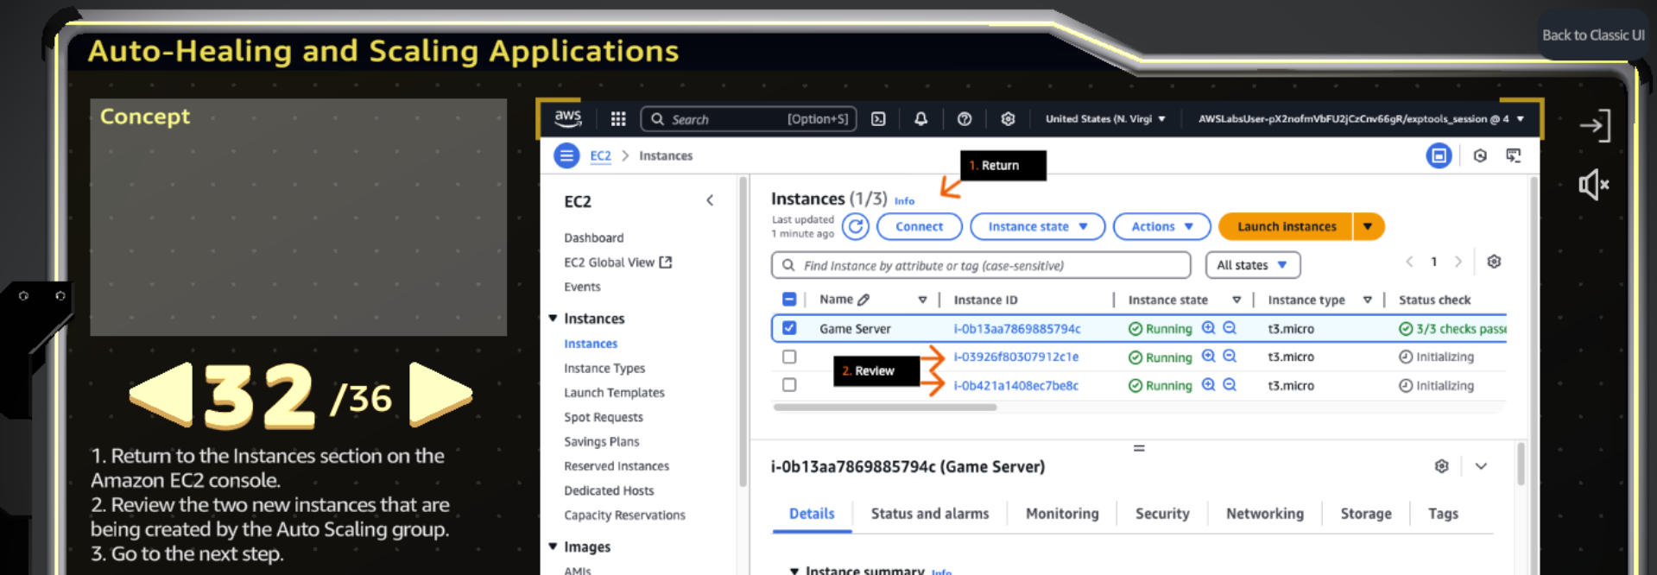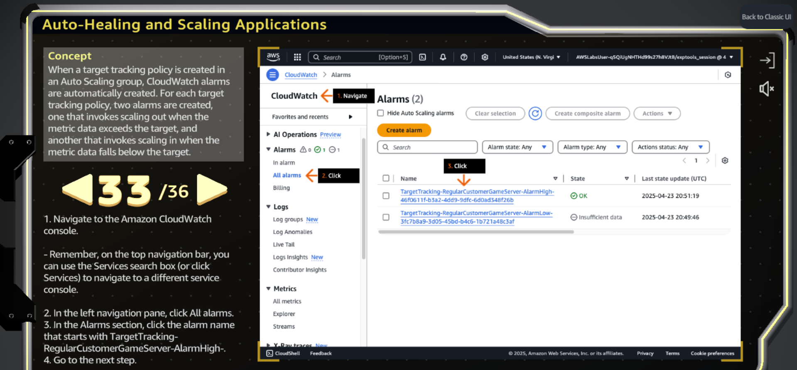

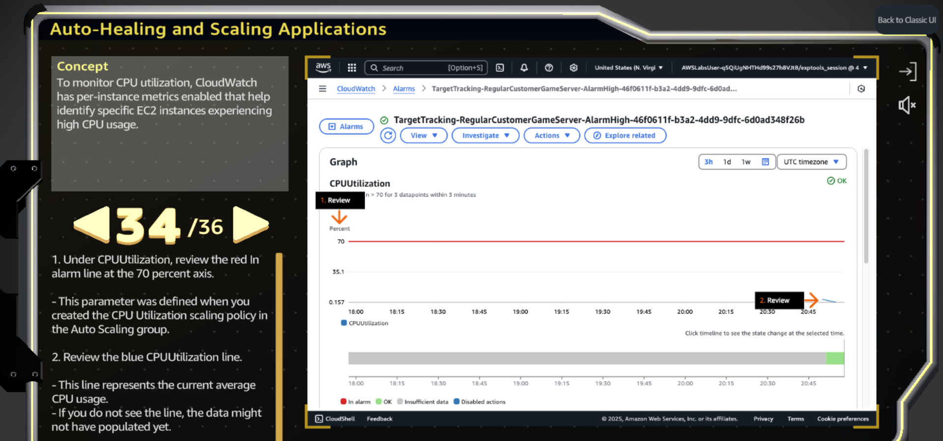

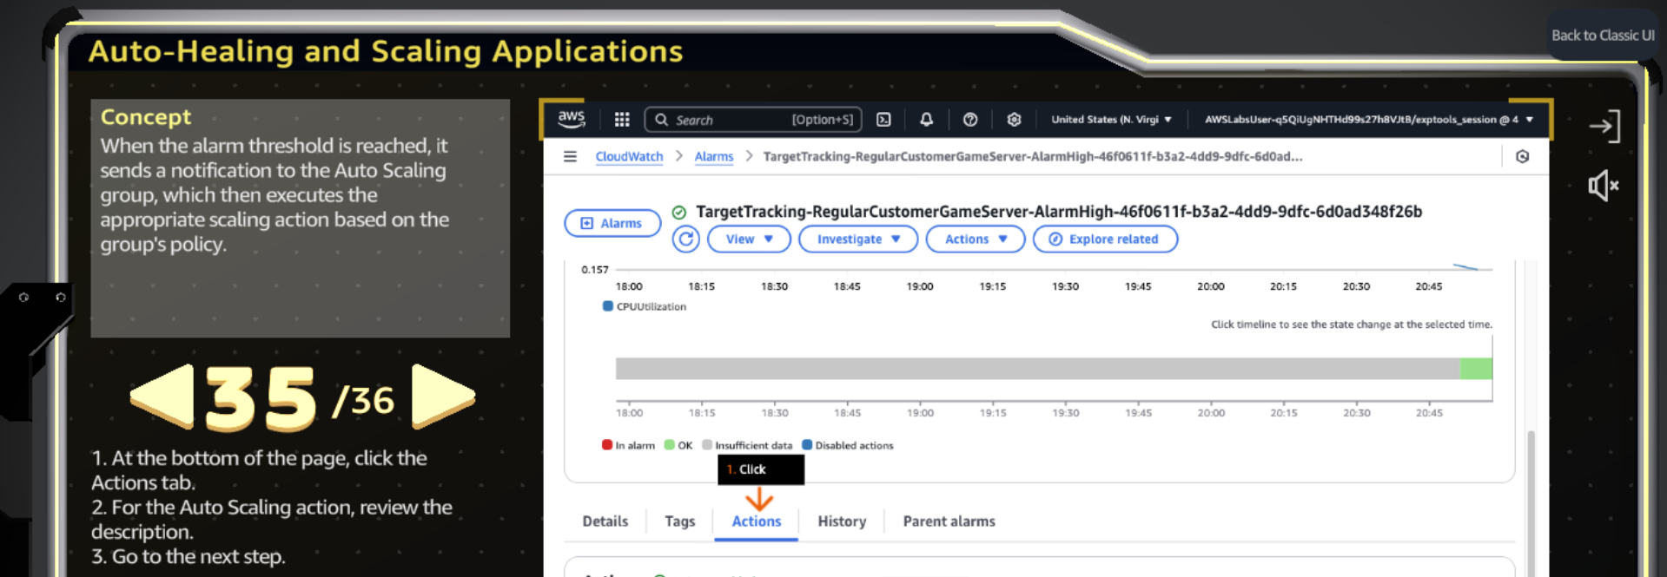

**Auto-Healing and Auto-Scaling Applications (Simplified Steps)**

**✅ Step 1: Create an AMI (Image) from an EC2 Instance**

1. Go to **EC2 → Instances**, select your running instance.
2. Click on **Actions → Images and Templates → Create Image**.
3. Give your image a **name and description**.
4. Check the box **“Tag image and snapshots together”**, then click **Create Image**.
5. Go to **EC2 → Images → AMIs** to **check the status**. Wait until it's **Available**.

**✅ Step 2: Create a Launch Template**

1. Go to **EC2 → Launch Templates → Create Launch Template**.
2. Name it and write a description.
3. **Check the box for Auto Scaling Guidance**.
4. In **Application and OS Images (My AMIs)**, select **Owned by me**, and choose the AMI you created.
5. Choose an **instance type** (like t2.micro).
6. Create a **new key pair**:
   * Give it a name.
   * Select **type as RSA**, and format as **.pem**.
   * Click **Create key pair**.
7. In **Network settings → Firewall**, select an **existing security group**.
8. Review everything and click **Create Launch Template**.

**✅ Step 3: Create an Auto Scaling Group**

1. Go to **EC2 → Auto Scaling → Auto Scaling Groups → Create Auto Scaling Group**.
2. Give it a name and select the **launch template** you created.
3. Choose a **VPC** (e.g., GameServerVPC).
4. Select **2 subnets** from different Availability Zones.
5. Skip load balancer setup (select **No Load Balancer**).
6. Set **Health check grace period** to **240 seconds**.
7. Set:
   * **Desired capacity = 2**
   * **Min capacity = 2**
   * **Max capacity = 4**
8. Choose **Target Tracking Scaling Policy**:
   * Name your policy.
   * Set **target metric** (like CPU).
   * Set **target value to 70**.
9. Skip to **Review** and click **Create Auto Scaling Group**.

**✅ Step 4: Add Scheduled Scaling Actions**

1. Open your Auto Scaling group → Go to **Automatic Scaling → Create Scheduled Action**.
2. Create a **scale-up action**:
   * Name it.
   * Desired, Min = **3**, Max = **4**
   * Recurrence = **Every week**
   * Set the **start time**.
3. Create a **scale-down action**:
   * Name it.
   * Desired, Min, Max = **0**
   * Recurrence = **Every day**
   * Set a **future date and time (e.g., 01:00 AM)**.